**SysEng 6104 Project Task 7**

**System Architecture Assessment Method**

Using the system benefit that is defined in earlier project tasks namely; system key performance attributes( MOE), fuzzy terms to assess the architecture, fuzzy statements and MOE, MOP, TPM formulate an architecture assessment method of your own and assess the Level-2 system architecture that you have developed in project task 6. You can select at least ten journal or conference proceeding papers that are related to architecture assessment that can help you in building your assessment model.

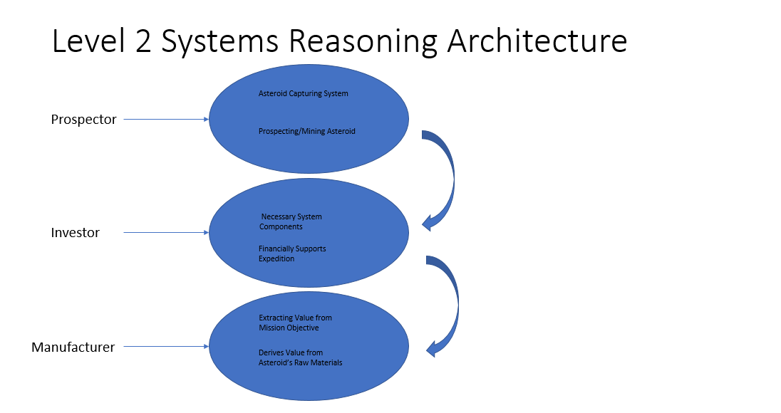

Before delving into the architecture levels, the reasoning about the architectures helps define the flow of the value of the system. Ultimately the system helps manufacturers to derive value from the raw materials at level 2 for further distribution in commercial products. Keeping this in mind helps generate an accurate portrayal of values at level-2 for the system’s architecture.

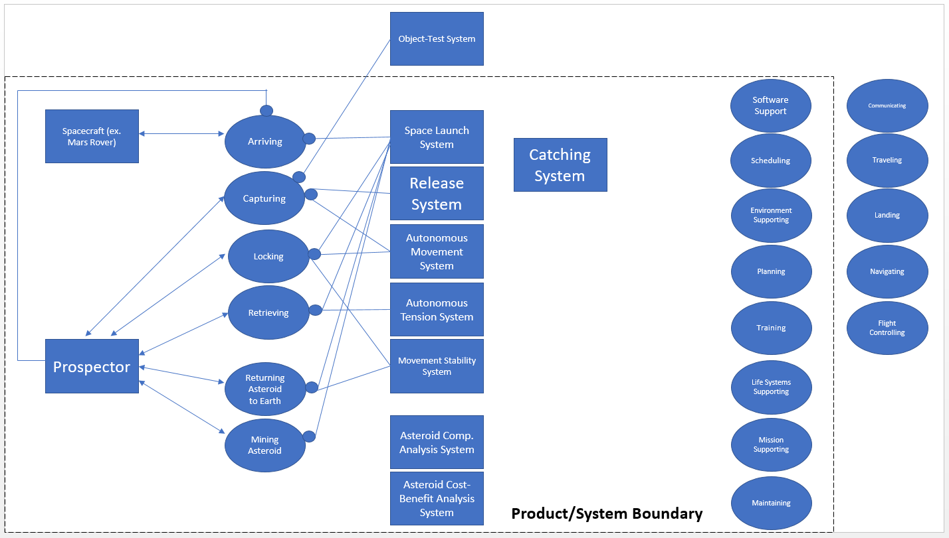

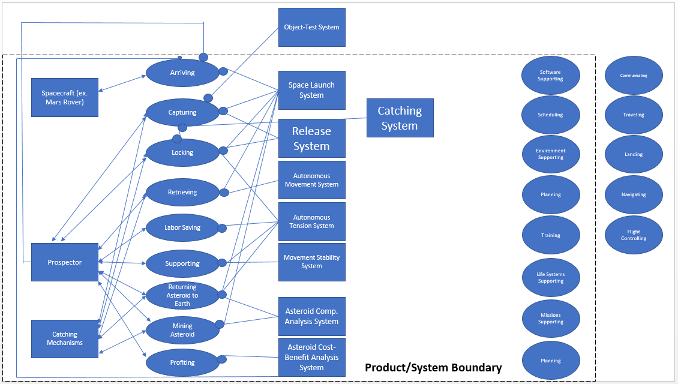

Based on the relevant, attached journal studies on asteroid mining systems or similar systems, the systems architecture flowing from level 2 to level 1, through the MOEs, MOPs, and TPMs can be assessed. For the level 2 architecture, 9 key functions were identified: arriving, capturing, locking, retrieving, labor-saving, supporting, returning Asteroid to Earth, mining Asteroid, and Profiting. The level 1 architecture consists of arriving, capturing, locking, retrieving, returning Asteroid to Earth, and mining Asteroid. Between level 1 and level 2, labor-saving, supporting, and profiting were added functions.

After consulting the attached journals, the usefulness of the level 2 functions tied better into the level 1 architecture:

Arriving: The function calls for arriving near an asteroid’s vincinity but this was left unintentionally vague. Architecture assessments pinpoint that most Asteroid’s currently under consideration are limited to Near Earth Asteroids (NEAs). The methods under consideration for asteroid mining mostly involve physically landing on the asteroid but since my method calls for capturing the whole asteroid, what would be considered the vincinity of the asteroid is vague. Vincinity in this case would be defined by the final design considerations of the system where the design determines the correct distance away from the asteroid for optimal catching. Arriving as a function for the most part is outside of the scope of the system since it only involves using pre-existing rockets/rovers or future-developed rockets/rovers to arrive near the vincinity with the capturing system on-board. Arriving needs to be included as part of the mission, however, mainly because it must integrate well with the systems used to arrive near the asteroid. To accomplish this, the capturing system must be relatively light-weight and small in size to not only fit but keep fuel costs low for the rocket/rover. The system must exhibit communications necessary to link back up with the rocket/rover for communication and find ways to integrate with and without an asteroid attached to the system.

Capturing: This method is more up-for-debate than the technicalities of how it would work. With enough resources used, this method could succeed and keep development and implementation costs low. Since an asteroid has never been captured nor intentionally moved, there is not an established best method in place for how to mine asteroids. Lasers have been explored as a method for mining resources as well as destroying asteroids, netting without metalloid reinforcements is a proposed method, and in-situ mining is another alternative. The materials used for the netting and for the reinforcements are being explored. The reinforcements would most likely be a derivative of Aluminum or a newly lab-developed proprietary metal by NASA that would be an aluminum-composite metal. A polymer composite would also be the favorite to use as the netting material. Part of what makes asteroid mining interesting, especially once venturing outside of Near Earth Asteroids, is that the materials used to capture the asteroid may need to utilize available resources closer to the source-asteroid because bringing a transportable asteroid-capturing system may not be an option for practical considerations like fuel and room. In this scenario, additive manufacturing could be utilized to develop the reinforcements and netting perhaps from materials available on the actual asteroid. The big picture is to surround the asteroid with at least the netting and space reinforcements at stability points throughout. To do this, the movement needs to be synchronized in such a way that its extension would be capable of slowing a massive high-velocity object. The stability points for the reinforcements is hard to comprehend on such a large scale but plentiful modeling tools exist to predict the pressure points of oddly shaped objects such as asteroids that can be scaled to their large size and topographical/density characteristics. How the netting would best surround the asteroid would also need additional testing. The netting would be released from the system while staying attached to the system and expand to surround itself but how? Working in conjunction with reinforcements adds many options to test and the best system may be one that allows for multiple expansion configurations depending on the asteroid characteristics.

Locking: The locking method would assess the stability of each reinforcement point and monitor the nettings pressure proximity around the asteroid, checking for any tears or imperfections. The reinforcements would be the main concern for locking outside of general quality checks of the netting. The pressure with which the netting would exert on the asteroid would ideally be capable of adjusting depending on the level of tightness needed but the reinforcements will handle the brunt of the asteroid’s disparaging movements. The locking method of the reinforcements poses a question of how best to secure the asteroid. Should there be drills on the end of each reinforcement point capable of drilling into the surface of the asteroid for stability? Should an adhesive be used to stick to the asteroid’s surface? Questions like these need further study to determine the best method but the situation may be highly dependent of the prospect asteroid’s composition. If the reinforcement locks only used adhesives it may work on some asteroid surfaces but not others. For less dense asteroids, drilling into the surface may not establish the same level of security at the same drill distance. Shorter distanced reinforcements may not need any sticking function other than supporting the netting.

Retrieving: This function is simply a reverse of the capturing function. While the netting and reinforcements would extend outwards to surround the asteroid, to retrieve the asteroid after locking it in place would require software communication to retract inwards enough for stability. The retraction to retrieve the asteroid means a solid connection has been established to hold the asteroid in place while supporting its eventual transportation.

Labor-Saving: The idea behind the system remains for it to be fully autonomous to support both NEA missions and deep space missions. For a fully autonomous system, proper visual tools and software compatibility must be in place. The mission may take many years to complete one asteroid mission so the up-front labor hours may be high but it would save costs down the road and possibly save lives too, it’s really the only practical way. Visual tools and telescopes need to be capable of surviving deep space environments as well as possible weather generation near asteroid surfaces. They need to be easily upgradeable without reconfiguring the hardware unless the hardware reconfiguration would be supported by another autonomous system. With the possibility of missions lasting many years, ideally the software would be programmed to allow for artificial learning and with network communications enabled, for data download/upload. Not only do visual subsystems need to be exceptional, the interfaces must be exceptional and account for common troubleshooting issues that may occur to be fixed without the possibility of human physically performing them. The system is labor-saving and software-heavy not because of convenience but out of necessity.

Supporting: The system’s support function exists to account for the heavy asteroid load now attached to the system. The flight characteristics and control drastically change from before attachment to after. The system must compensate for this added load and still configure in a way to support transport to the intended destination. The best way to support the attached asteroid now that it would be locked into place could be studied to determine where precisely the asteroid belongs after attachment. With proper placement, the asteroid may even save the need for added fuel if boosters can give it proper momentum to propel it back to Earth. Software would need to account for this added mass and find ways to monitor the trajectory of the system as well as the stability of the asteroid.

Returning Asteroid to Earth: With the asteroid locked and stabilized, many methods might prove best for transporting. The system’s plan is to take back the whole asteroid but perhaps it could be partitioned to only take the essential resources back if it makes transport easier. An emergency asteroid dislodge procedure could help abandon the asteroid if determined that a crash or the fleet burning up was inevitable. The returning asteroid function means the system either needs to either utilize boosters or find ways to integrate back into a rocket/rover for transportation with an asteroid now attached. Flight simulation studies and analysis on-board may determine the best way to transport.

Mining Asteroid: In the context of this system, mining the asteroid means more for preparing the asteroid to be mined. After transporting the asteroid back to Earth, the asteroid cannot simply be plopped anywhere. A designated large location with tools in place to properly manufacture the asteroid would be ideal. In past space missions, the space bodies have returned to Earth into the ocean but without risking damage to the asteroid, this would not be an option. A proper mining site is outside of the context of this system but the system needs to keep in mind how best it would integrate into an ideal mining site upon its return.

Profiting: As a secondary function, profiting ties directly into the mining of the asteroid which isn’t the primary function of the system. Profiting depends in large part, on the type of mission. If the mission is to use asteroids as fuel sources along the ways to deep space journeys then its profit relies not so much in extracting their resources for common Earth use but for cutting costs and possibly being the only method to fuel deep space travel. The estimated greatest value asset of asteroids for such a mission would be water as a fuel source. For other missions, the various rare-on-Earth metalloids might be the most valuable assets. Although current estimations do not show a dire need for even some of the rarest asteroid metals, dwindling resources on Earth may skyrocket their value. The immediate value of the asteroid’s metals is more of a science to predict but the future value of the same metals is more of a guessing game depending on the availability of said resources on Earth. The development of new technologies across all sectors on Earth is driven by supply-demand of precious metals that may be a limited hot commodity in the future that requires extraterrestrial travel.

The level-2 system architecture added 3 new functions (labor-saving, supporting, and profiting) that contributed to secondary derived values. These functions and operands flow back up to the level-1 architecture to further breakdown all of the essential questions of the system and its performance in a mission context. The level-1 functions have already been described and their design considerations expanded on. The labor-saving, supporting, and profiting functions give a clearer picture of technical and practical aspects of how the system better fits into a mission concept.

Since the level-1 architecture needs no further explanation following a level-2 explanation of functions, it is best to examine how the level-1 architecture fits into the MOEs, TPMs, and MOPs technical aspects of the system. See the attached Assignment 4.docx for a breakdown of all these. The MOEs, TPMs, and MOPs flow down from the level-1 architecture as more of a baseline for describing the system. The MOEs, TPMs, and MOPs guide the technical performances of the system so when placed into a level-1 architecture context, they support the intended mission and how the system will function. All of the different technical measures and ways of assessing the architecture in Assignment 4.docx serve two purposes: to quantify the system’s effectiveness and provide baselines to be met for performance.

The assessment model simply flows from level-2 down to the MOPs, TPMs, and MOEs to determine if each characteristic is successful and how successful it is for its intended purpose in the system. Establishing values for each MOE, MOP, and TPM would clearly define a sufficient assessment model. See attached Assessment Thrshhold.xlsx to see the Assessment Model in progress. The units of measurement have been defined and although more study is needed to determine realistic goal values for each function, sub-function, and sub-sub-functions, it can be seen how the model would flow and the category for each metric of success.

**References (all attached for convenience):**

A systematic Assessment of Asteroid Redirection methods for Resource Exploitation.pdf

Architecture Assessment of HLLV Candidates.pdf

Assessing Impact of Epistemic and Technological Uncertainty on Aircraft Subsystem Architectures.pdf

Asteroid Mining.pdf

Electrical Propulsion Architecture Assessment via Signomial Programming.pdf

High Mass Mars Entry, Descent, and Landing Architecture Assessment.pdf

Integrated Assessment of Aircraft and Novel Subsystem Architectures in Early Design.pdf

Integrated Assessment of Vehicle-level Performance of Novel Aircraft Concepts and Subsystem Architectures in Early Design.pdf

Low-Thrust Trajectory Optimization Tool to Assess Options for Near-Earth Asteroid Deflection.pdf

Optimal Architecture for an Asteroid Mining Mission: Equipment Details and Integration.pdf

System-Level Assessment of Active Flow Control for Commercial Aircraft High-Lift Devices.pdf